**Software Development Tools**

**laboratory work 4**

**EXERCISE 1 – Analyze Architecture Diagrams**

The purpose of this exercise is to give you concrete practice in evaluating software abstractions.

In this exercise, you will study several architectural diagrams to identify how they could be used. You will also practice identifying and classifying ambiguities.

ACTIVITIES

Perform each of the following activities. If you have questions, issues, or doubts, please ask for help and do not just guess.

1. Individually take 5 minutes to review the purpose of each of the models in the canonical model structure. Think about them in terms of what kinds of elements each depicts and what they are used for – what kinds of questions they can help answer.
2. For each of the cartoons on the following pages, do the following:
   1. Discuss what kinds of questions the diagram could help answer then create and record one question that the cartoon could help answer.
   2. Take 5 minutes as individuals to study the cartoons for ambiguities. Write them down.
   3. As a team, compile the identified ambiguities into a single list.
   4. For each ambiguity, decide whether or not your team feels the ambiguity is likely an error and should be referred back to the architect or whether it is clearly something that can be left open to downstream design and coding. On your paper record whether it should be Referred or Left Open. If your decision that it should be referred then describe why your team things so.

VIEW DIAGRAMS:

1. 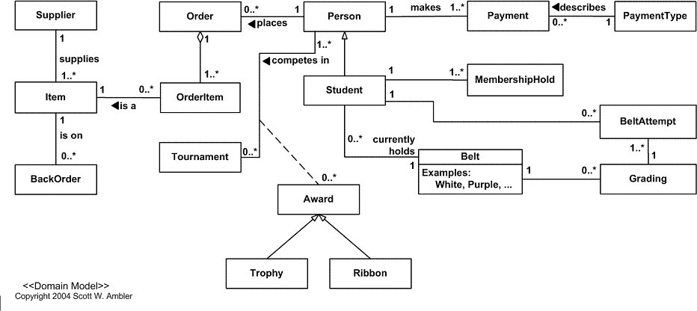

1. 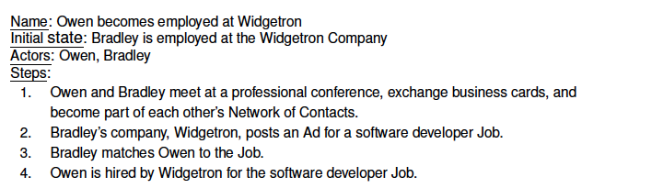

1. 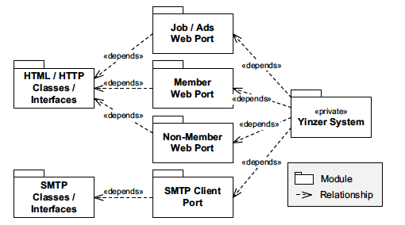

1. 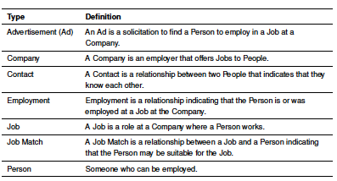

1. 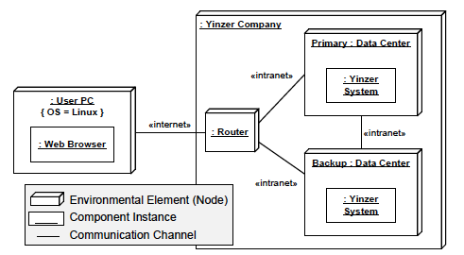

F.

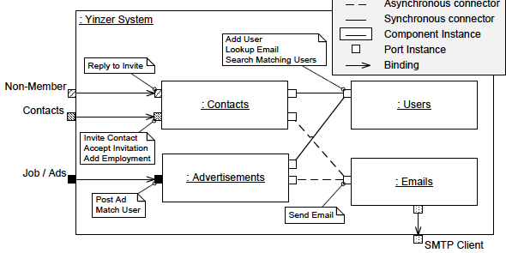

**Exercise 2: Identifying View Types**

PURPOSE

The purpose of this exercise is to give you concrete practice in identifying different kinds of views by thinking about how they would be used.

In this exercise you will study several architectural diagrams and for each, identify with which of the three models from the canonical model structure it is associated.

ACTIVITIES

Perform each of the following activities. If you have questions, issues, or doubts, please ask for help and do not just guess.

1. Individually take 5 minutes to review the purposes of each of the models in the canonical model structure, thinking about them in terms of what kinds of elements are depicted in each and what they are used for – what kinds of questions they can help answer.
2. For each cartoon above, using the results from Exercise 1, discuss what kind of structure the cartoon represents, and then identify and record with which of the canonical models it is associated. Also describe the basis for your decision.

**EXERCISE 3 – Exploring ATM Domain via the Information Model**

PURPOSE

The purpose of this exercise is to give your team an opportunity to refine your understanding of the ATM domain (your project domain) through creation of a textual and graphical information models.

ACTIVITIES

Perform each of the following activities. If you have questions, issues, or doubts, please ask for help and do not just guess.

1. Get into teams.
2. Since we assume you have never worked in the ATM domain (your project domain) we assume you have limited understanding of that domain. But, we do assume you have interacted with an ATM (your project).
3. As a team, revisit the roles you identified when developing your use cases. For each role, using the example in Fairbanks section 8.2 create definitions for each of the roles. The definitions should include statements that define the relationships among the roles and between the roles and the ATM (your project). Capture these definitions in a textual information model.
4. Discuss the possibility that there are other roles you did not consider earlier in the course and add definitions for those.
5. Consider the things, other than roles, that are in the ATM domain (your project domain) such as the physical parts of the ATM machine, accounts, etc. Define these in your textual information model.
6. Using the Fairbanks figure 8.2 as a guide create a graphical information model that depicts the relationships between the roles.
7. When your team has completed the previous steps of the laboratory work, upload it to DL.